

**DEBRE BERHAN UNIVERSITY**

**COLLEGE OF COMPUTING**

**DEPARTMENT OF INFORMATION SYSTEMS**

**A PROJECT ON: WEB BASED POPULATION AND HOUSING CENSUS MANAGEMENT SYSTEM FOR DEBRE BERHAN**

**PROJECT SUBMITTED IN PARTIAL FULFILLMENT OF THE REQUIREMENT FOR THE AWARD OF THE DEGREE OF BACHELOR OF SCIENCE IN INFORMATION SYSTEMS**

### SUBMITTED BY

**NAME OF STUDENTS ID NO  
1. YESHEWAGET GEBRESELLASSIE……………………..……DBUR/1811/11  
2. FETENE ERKUTENA…………………………………………… DBUR/1654/11  
3. EPHERME YIRGA………………………………………………. DBUR/1729/11  
4. METI FEYISA……………………………………………………. DBUR/1871/11  
5. YONASE MARYE………………………………………………… DBUR/1775/11**

**PROJECT ADVISOR: KINDE ALEBACHEW**

**JUNE,2022**

**DEBRE BERHAN UNIVERSITY, DERHAN BERHAN, ETHIOPIA**

# APPROVAL FORM

This is to confirm that the project report entitled **Web Based Population And Housing Census Management System For Debre Berhan** submitted to **Debre Berhan University, College of Computing Department of information systems** by:

Name Signature

**1. Yeshewaget Gebresellassie** ----------------------  **2. Fetene Erkutena** ----------------------  **3. Epherme Yirga**  ----------------------  **4. Meti Feyisa**  ----------------------  **5. Yonase Marye** ----------------------

Advisor Name Signature Date

Department Head Name Signature Date

Examiner 1 Name Signature Date

Examiner 2 Name Signature Date

Examiner 3 Name Signature Date

Examiner 4 Name Signature Date

# ACKNOWLEDGMENT

First, we would like to thank Almighty (omnipotent) GOD, for giving strength; he has given us throughout our life and the project. Secondly, we would like to express our deepest gratitude to our advisor instructor kinde Alebachew for her excellent guidance, caring, patience, and providing us with an excellent atmosphere for doing this documentation. We would also like to express our gratitude to debre berhan population and housing census officer who gave enough information for our interviews with patience and full of voluntariness.

Table of Contents

SUBMITTED BY 27

APPROVAL FORM 28

ACKNOWLEDGMENT 29

CHAPTER ONE 6

INTRODUCTION 6

1.1 Introduction 6

1.2 Background of the project 7

1.3 Statement of the problem 7

1.4 Objective the Project 8

1.4.1 General Objective 8

1.4.2 Specific Objective 8

1.5 Scope of the Project 9

1.6 Significant of Study 9

1.7 Beneficiaries of the system 9

1.8 Feasibility study of the new system 10

1.8.1 Technical and Operational feasibility 10

1.8.2 Economic Feasibility 10

1.8.3 Political feasibility 11

1.9 Methodology and tool 11

1.9.1 Data gathering methodology 11

1.9.2 System Analysis and Design Methodology 12

1.9.3 Software requirements: 12

1.9.4 Hardware requirements: 12

1.9.5 Language 13

1.10 Testing technique 13

1.10.1 Black box testing 13

1.10.2 White box testing 13

1.11 Assumption and constraint 13

1.11.1 Assumption 13

1.11.2 Constraint 14

CHAPTER TWO 15

2.1 Introduction 15

2.2 Players in the existing system 15

2.2.1 Enumerator: 15

2.2.2 Supervisor: 15

2.2 Major functions 16

2.3 Business Rules 16

2.4 Report, forms and other documents generated in the existing system 17

2.4.1 Report generated 17

2.4.2 Forms used in the existing system 17

2.5 Problem of the existing system 19

2.6 Practice to be preserved 20

2.7 Proposed solution 20

2.8 Requirements of the Proposed System 20

2.8.1 Functional requirements 20

2.8.2 Non- functional requirements 21

CHAPTER THREE 22

SYSTEM ANALYSIS 22

3.1 Introduction 22

3.2 Use Case Modelling 22

3.3 Use case description 23

3.4 Use case Scenario 24

3.5 Use Case description 24

3.6 Analysis level Class Diagram (Conceptual Modelling) 29

3.7 Sequence diagram 30

3.8 Activity diagram 34

3.9 State chart diagram 40

3.10 User interface 42

3.11 User Interface Prototyping 44

3.12 Supplementary specifications 45

3.12.1 Business Rules 45

3.12.2 Constraints 46

CHAPTER FOUR 47

SYSTEM DESIGN 47

4.1 Introduction 47

4.2 Purpose of the system 47

4.3 Design goal 47

4.4 System Architecture 48

4.5 Class Modelling 49

4.6 Component Diagram 51

4.7 Subsystem decomposition 52

4.8 Deployment Diagram 53

4.9 Data Dictionary 54

4.10 Database Design 57

Reference 59

List of table

Table 1: login description 25

Table 2 view description 25

Table 3 for fill census form description 26

Table 4 search description 26

Table 5 register enumerator description 27

Table 6 register supervisor description 27

Table 7 report generate description 28

Table 8 manage account description 28

Table 9 view publication description 28

Table 10 *Administrator table* 55

Table 11 supervisor table 56

Table 12 enumerator table 56

Table 13 census data table 57

List of figure

Figure 1 generated report 16

Figure 2 Area identification form 17

Figure 3 Type of residence and housing identification form 18

Figure 4: use case diagram 22

Figure 5: conceptual modelling 28

Figure 6: Sequence diagram for login 29

Figure 7 : Sequence diagram for fill form 30

Figure 8 : Sequence diagram for update 31

Figure 9: Sequence diagram for delete 32

Figure 10 : Activity diagram for login 33

Figure 11: Activity diagram for fill 34

Figure 12: Activity diagram for update 35

Figure 13: Activity diagram for publish 36

Figure 14; Activity diagram for add actor 37

Figure 15: Activity diagram for search 38

Figure 16: State diagram for login 39

Figure 17: State diagram for populate 40

Figure 18 : State diagram for generate report 41

Figure 19: user interface for home page 42

Figure 20 : user interface for fill census form 42

Figure 21: user interfaces for login 43

Figure 22: user interface prototype 44

Figure 23: Software Architecture 48

Figure 24 : Class Modeling diagram 49

Figure 25 : component diagram 50

Figure 26: Subsystem decomposition diagram 52

Figure 27: deployment diagram 53

Figure 28: database design 56

# CHAPTER ONE

# INTRODUCTION

## Introduction

Population and housing censuses are the foundation of statistical systems, providing benchmarks of a country's population and housing stock, and baseline information for the production of other statistics.

Population Census the total process of collecting, classifying evaluating, analysing and publishing or distribution of demographic, economic and social data of the population during a certain period of time. Population considers an essential element for production and distribution of material wealth, for planning and implementation of economic, social development or administrative activity or scientific research requires the existence of reliable and detailed data on the size, distribution and composition of population. Population Census forms a most important source, of these basic statistics for comparison.

The increasing complexity of modern life means a greater need to plan housing, schools, roads, transportation, and a vast range of social and economic requirement for nation. This cannot be done without a detailed count of the population. Census is being officially managed by some organizations or government, for example the National Population Commission (NPC). Ethiopia has so far conducted 3 Population and Housing Censuses (PHC) in 1984, 1994, and 2007. The preparations to conduct the 2017 PHC (4th Census) are currently underway, and one of these major undertakings is related to Census data capturing and processing.

The installation of computer in these organizations or bodies that manages census information will assist not only in fast-recording information but also in solving certain problems, which cannot be easily resolved manually. The human resource of any enterprises is considered to be their most valuable assets, if they are properly harnessed and are well motivated to perform their assigned tasks in such a manner as to enhance the enterprises goals and objectives.

Therefore, adequate population records will provide all the necessary information that is associated with people, which include the size of the population, age structure, educational attainment, labour force and socio-economic characteristics, unlike in the manual method which makes access to data and information very tedious. The integration of different databases so that these databases can be merged and processed together and mainly other reasons, prompted the researcher to develop software for this organization, National Population Commission (NPC).

## Background of the project

Census taking in Ethiopia can be traced to have started from as far back as 1989 year. Since then, there have been several attempts to count Ethiopian population. However, these censuses are characterized by some difficulties and deliberate and ill-minded attempts to inflate population figures; just in favour of one geopolitical zone or the other. This does not and cannot represent the nation’s image as regards to human population. As a result of this, the National Population Commission (NPC) was established using the Decree No. 43 of 1989. The brain behind this was to have successful censuses each time and as well accurate demographic data. It is no doubt that this Commission (NPC) was vested with a lot of powers and functions some of which are;

* To undertake the periodic enumeration of the nation’s population through census, sample surveys, etc.
* To establish and maintain the machinery for continuous and universal registration of births and deaths
* To collect, collate and publish data on migration statistics
* To reach and monitor national population polity and set up national population information data bank.

The system currently uses manual system such as paper for the management system which leads the system to be inefficient. Some of the problems are material records issue, searching and getting of different data it takes long time; loss of document, security problem and retrieval problem to be occurred.

## Statement of the problem

There are many problems affecting the population and housing census from maintaining a steady reliable figures and estimates. These are the more reasons, why the current system have faced problem;

* Inadequate manpower
* Lack of equipment’s
* Poor and unstable organisation
* Manual bulk carrying of data
* Requires more Resources: Consumes more resources such as manpower, cost, paper, pen, transportation, and storage place.
* Lack of automated statistical manipulations.
* High Data redundancy and erroneous data storing.
* The current system is not efficient, flexible, reliable, available and difficult to get data.

## Objective the Project

### General Objective

The general objective of this project is to develop web-based online census system for Debre Berhan city.

### Specific Objective

To achieve the above mentioned general objective, the project includes the following specific objective

* To develop web-based system that stores and retrieves all information on human population.
* To create user interface for enumerators to login in to the system and organize the data adequately to solve the security problem.
* To develop a reliable system that could be used in collecting data/information on human population.
* To develop a system that will support direct access to the specific and required information
* To Reduce the time taken by management in coming up with concrete decisions
* To deal with data redundancy within the database
* To Help in efficient collection, storing, updating , processing and analysis of data for ease in manipulation
* Report

## Scope of the Project

The major aim of the project is to design a system that will have all information about human population and retrieving of data whenever needed in the society. It focuses on the registration, retrieval and management of information about individuals in the society.

## Significant of Study

The proposed project will solve problem associated with the acquisition, storage, and retrieval of information on human population with ease.

* A timely retrieval of information is anticipated with efficiency and reliability.
* It will provide security to data that are unauthorized, users will not gain access to those files and fraud will be minimized in the society which will lead to improvement in administration processes.

The proposed system focused on Debre Birhan city statistics agency and covers only the population and housing unit.

## Beneficiaries of the system

The beneficiary of this system includes:

* Administrator: - unlike the existing system the proposed system would enable the admin to manage the system much more easily since it’s mostly done digitally.
* Supervisor: -benefit from the system by easily supervising the enumerator online by using browser and avoiding physical work load.
* Journalists and researcher can access or get organized data easily from the system to update publish and use in related articles for magazines and blogs.
* Government ministries and Local authorities: - They will get error free census data to provide appropriate budgeting for infrastructure or other services and for future policy making.
* Private and public companies:- They can access or get organized and accurate data for different purpose.
* JOB opportunity: admin, supervisor and enumerator.

## Feasibility study of the new system

The feasibility study is the preliminary study that determines whether a proposed system project is financial, technically and operationally viable. The alternative analysis usually include as part of the feasibility study, identifies viable alternatives for the system design and development.

### Technical and Operational feasibility

Our project is technically feasibly b/c it is fast and easily to use but in manual system it is difficult since it is manual

* Our proposed system is time and resource saver in census process it have no need more resource as existing system
* Assessing the size of the manpower, census form and other equipment required for the census is simple
* Easily Provide comparable workloads to the enumerators
* Ensure that the census is completed in the specified time
* Operationally our system is not complex but in manual Data capturing for the 1984 and 1994 Censuses was carried out using the traditional keyboard-based data entry method.
* Our proposed system is digital so it reduce human power the supervisor assign people for each zone, worda, kebele
* Our project has a user-friendly interface that can be implemented easily and can perform many tasks that can be used by users.

### Economic Feasibility

In the existing system, many people are involved in the process but in the proposed system, number of persons involved be reduced drastically.

After this project finished it will reduce the cost of paper, pen, and employees to organize the papers will be avoided since we automate the system from manual system so that our project is economically feasible.

### Political feasibility

Our project will not conflict with the rule and regulation of Ethiopian constitution and Ethiopian statistical agency rather it gives advantage to our country.

## Methodology and tool

### Data gathering methodology

The following data gathering methodology are to develop the proposed system;

* **Interviewing** **- :** A planned meeting during which the interviewer obtains information from the interviewee. We interview the Coordinator. This will enable us to know the requirements and if any training will be required before the system is implemented.
* **Observation –** we have observed about Ethiopian population and house census in order to gain basic informationthis help us to see the problems the enumerator, supervisors are facing. This can be done by attending one census process. In the existing system there is different problem in terms of time and economically, so our system answer this problem,
* **Questionnaires**:-It contains fixed-response questions about various features of an organization. This also another data gathering methods that are used for collecting information from the stake holder. This can be in terms of written paper we have distributed for individuals for Debre-Birhan population and housing census branch.
* **Analysis and design:** We choose to use iterative model of software process model. This is due to the fact that this model matches our situation. We plan to develop the basic features in the first iteration and continuously add more features as we progress to the final iterations. Each iteration consists of a complete system development life cycle i.e. requirement gathering, design and development, testing and implementation.

We choose iterative model because of iterative model approach is suitable for changing requirement. In addition, easier risk management and promote team work. Furthermore, we can add new feature to the system.

### System Analysis and Design Methodology

We choose to use iterative model of software process model. This is due to the fact that this model matches our situation. We plan to develop the basic features in the first iteration and continuously add more features as we progress to the final iterations. Each iteration consists of a complete system development life cycle i.e. requirement gathering, design and development, testing and implementation.

We choose iterative model because of iterative model approach is suitable for changing requirement. In addition, easier risk management and promote team work. Furthermore, we can add new feature to the system.

### Software requirements:

* Windows 7 or higher
* Visual Studio 2010
* Microsoft Office 2010: this software is used to write the documentation of the system.
* Laravel: is used front end of the system front end of the system.
* Latest Browsers: is used to search what we want.
* Xampp apache, MySQL: we use Xampp as our server and data base.
* Edraw Max: used software is used to model the system model.
* HTML: is used to develop the structure of the system and the front end of the system.

### Hardware requirements:

* Processor – dual core
* Hard Disk – 5 GB
* Memory – 1GB RAM
* Desktop computer: : We use a desktop and laptop computer for all project activities
* Printer: to print our documentation.
* 16 GB flash drive used to make backup of important information in case of any damage.

### Language

* PHP (We use PHP language for the system development; back end to create user interface and our system (software) will be compatible on all hardware).back end
* SQL: used for database
* Java script: to validate the forms
* HTML: is used to develop the structure of the system and the front end of the system.

## Testing technique

We will use two different methods of testing technique.

### Black box testing

The technique of testing without having any knowledge of the interior workings of the application is Black Box testing. The tester is oblivious of to the system architecture and does not have access to the source code. Typically, when performing a black box test, a tester will interact with the system's user interface by providing inputs and examining outputs without knowing how and where the inputs are worked upon.

### White box testing

White box testing is the detailed investigation of internal logic and structure of the code. In order to perform white box testing on an application, the tester needs to possess knowledge of the internal working of the code. The tester needs to have a look inside the source code and find out which unit/chunk of the code is behaving inappropriately.

## Assumption and constraint

### ***Assumption***

* The system should connect to the network and internet.
* The users should have smart phone or computer with sufficient knowledge about usage.
* The users must know an English language

### Constraint

Constraints are situations or uncomfortable conditions that restrict us from fully achieving the goal of our project. The following are problems that hinder us from successfully accomplishing our task.

**Technical problems**: Our knowledge and experience towards project work is not that much sufficient and we kill more time on studying and understanding some references and supportive courses about project work.

**Unfortunate failure of system**: To handle this problem the teams have some method to resist not completely but partially by using back up mechanisms using flash disks and by storing the data on our Email account.

**Power problem**: we tried to use laptops to cover the gap happened to our project during power failure.

**Time management problem**: we solve this problem by working cooperatively, divide our time by schedule for each phase of the project and we try to use this schedule effectively.

# 

# CHAPTER TWO

**DESCRIPTION OF THE EXISTING SYSTEM**

## 2.1 Introduction

As it is described in the first chapter the existing system is done manually. Registration, documentation, writing, search and retrieval of the specific information of the population is done manually. This type of system makes the worker to document erroneous and redundant information, lack of automated statistical manipulations, decreases flexibility and it also consumes the time of the worker for completing specific task.Moreover, there is no logging function available to make the system secure.

When analysing an existing system, note is taken on how the existing system works or the procedures on how jobs and activities are been carried out in the organization. During system analysis, investigation of an existing system in order to understand its operation is carried out for better understanding of the existing system and the introduction of more efficient and economic means of achieving the desired goals is also made.

## 2.2 Players in the existing system

### 2.2.1 Enumerator:

The Enumerator is the one who has a privilege to collect and fill the census by collecting the information of the people manually. Each enumerator is given the map of an enumeration area along with other census document and he/she is responsible to record all person and Households in that enumeration area without omission and duplication. Each enumerator has a national enumerator number given by Debre Berhan city statics agency to identify each and every enumerator. The enumerator validates the collected census by its name and signature.

### 2.2.2 Supervisor:

The supervisor is the one who has a privilege which is given by Debre Berhan city population and housing census to supervise and validate the collected census data by using its signature. Supervisor is assigned to a supervision area and is responsible for ensuring the quality of the information collected in the area of his/her jurisdiction.

## 2.2 Major functions

**Data Input:** Data has been inputted directly by the enumerator.

**Data Processing:** Count the inputted information collected by the enumerator manually.

**Data Output:** The data collected so far is recorded in a document and the document delivered to the Debre Berhan city population and housing census.

## 2.3 Business Rules

A business rule is an operating principle or policy the software must satisfy. It often pertain to access control issues, business calculations, or operating polices and principles of the system. Therefore, our new system has the following business rules:

BR1: Enumeration area should be mapped and unique code is given for each area.

BR2: A person to be counted as a member of a given family he/she must live there at least for 6 months.

BR3: A newly married person is counted with his/her new family regardless of the time she/he started to live with her/his new family.

BR4: For one woreda 6 enumerators and one supervisor should be assigned.

BR5:200 families are given to one enumerator for urban areas.

BR6: The enumerator is given up to 150 families for rural areas.

BR7: The enumerators should be well trained.

## 2.4 Report, forms and other documents generated in the existing system

### 2.4.1 Report generated

In the existing system, report was generated by a manual system from the collected information.

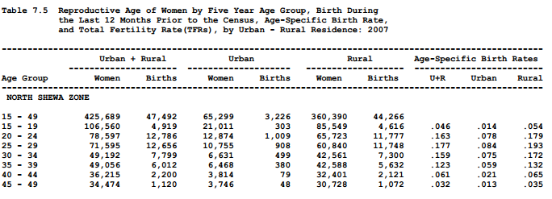

Figure 1 generated report

### 2.4.2 Forms used in the existing system

This form sections are used to collect data from the population Area identification

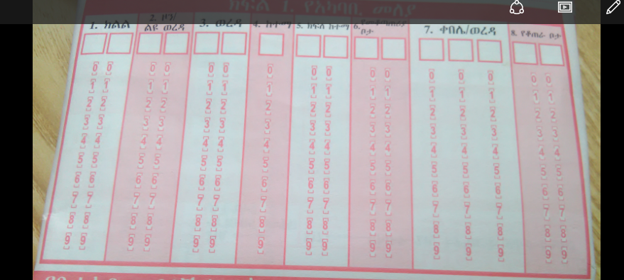

Figure 2 Area identification form

**Type of residence and housing identification**

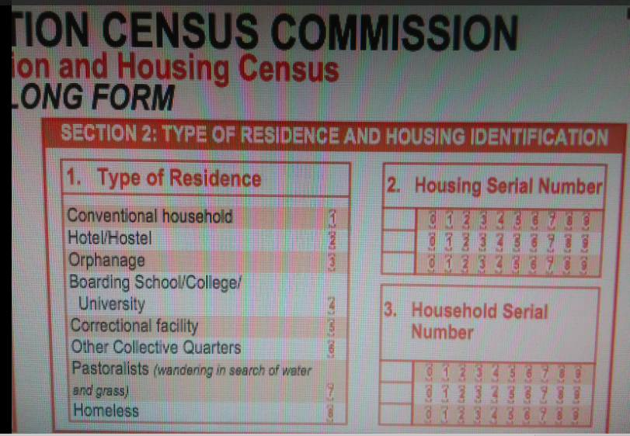

Figure 3 Type of residence and housing identification form

## 2.5 Problem of the existing system

**Performance:**

In the existing manual system there are more paper work, and didn’t respond very fast.

***Input:*** In the existing system data was collected door to door by the enumerator.

***Security:*** In the existing system there is no data security mechanism to protect the collected data.

***Efficiency:*** Since the existing system is manual it didn’t provide efficient data.

## 2.6 Practice to be preserved

* Classification of census area by zones to identify the specific area to enumerator.
* Enumerator fills the census by collecting the information of the people.
* Giving code for the enumeration area.

## 2.7 Proposed solution

We are going to improve the drawbacks of the existing system by developing an automated, user friendly and interactive graphical user interface system which will:-

* reduce complexity of existing system,
* manage time effectively,
* make work easy,
* make the data error free
* utilize available resource effectively,
* Enhance the efficiency and diversification of services activities

## 2.8 Requirements of the Proposed System

* Here we have two requirements.

### 2.8.1 Functional requirements

The main functional requirements of this system are:

* Add Employees
* Manage Employees
* View Reports
* Searching of data.
* Login
* View new Request.
* View Corrected Request.
* Validated Members
* Reject Member, and Ask for details.
* Add Family Member (with details like name, dob, sex, email, phone, Education, Occupation, Address, Area, City, State) specify if any other,
* Upload ID Card / birth certificate / Document for each Member
* The system shall record information of persons and housing unit.
* The system shall display the information of individuals.

### 2.8.2 Non- functional requirements

The non-functional requirement of the system deals with how well the system provides service to the user.

* **Performance:**

***Easy to use*:** unlike manual the automated system is easy to use.

***Fast and reliable:***The time needed to access the data is much less than the existing system.

* ***Maintainability*:** To ensure that the system continues to work properly by checking it regularly and making repairs and adjustments if required.
* ***Scalability:*** The system should provide flexibility and production of new versions suited for new environments and changing needs.
* ***Usability*:** The system should be easy to use by all.
* ***Availability***: The system should be up and running whenever needed.
* ***Security and access permission****:* the system should provide controlled access to information while on transmission, only authorized users should access and modify data.
* ***Supportability:*** since our project is done by php, the code can run in any browsers.
* ***Legal:*** our group uses paid version of software’s to develop the system.
* ***Interface:*** our group designs the user interface by php and css to make the interface more attractive.

# CHAPTER THREE

# SYSTEM ANALYSIS

# 3.1 Introduction

System design can be regarded as the drawing, planning, sketching or arranging of many separate elements into viable unified whole. While the system analysis phase is concerned with the question of what the system is doing and what it should be doing to meet user’s requirements, the system design phase centres on how the system is developed to meet the requirements.

The goal of the chapter is to prepare the designer of the project needs and requirements before the actual system is implemented. The system is first evaluated to verify how it operates, and then proposed system is designed of its specifications with technological options. It is a description of the structure of the software to be implemented, the data which is part of the system, the interface between system component and the algorithms used. The objective of this document is to detail the operation of the information system. The design document will hence help in the final design of the system. Graphical representation will be used to create a clear understanding and expected graphical user interface.

## 3.2 Use Case Modelling

Use cases are used to represent functionality of the system. Use case focused on the behavior of the system from external point of view. Use case describes a function provided by the system that yields a visible result for an actor. An actor describes any entity that interacts with the system like administrator, supervisor and enumerator.

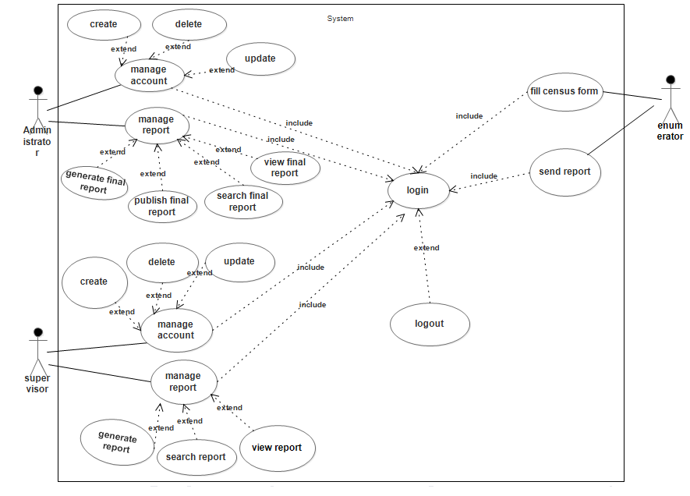

Figure 4: use case diagram

## 3.3 Use case description

**Use case diagrams** are usually referred to as behaviour diagrams used to describe a set of functions that some system or systems should perform in collaboration with one or more **external users** of the system. .

Each use case should provide some observable and valuable result to the actors or other stakeholders of the system.

The proposed system use case includes the following:

* Login
* Create/Modify account
* View census report
* Fill census form
* Manage census data
* Search
* Add enumerator
* Generate report

## 3.4 Use case Scenario

A scenario is a sequence of steps that represents a single use case execution. It made up of a number of simple, discrete steps that designated as performed by either the “System” or a “User”. This scenario considers the goal of describing our project fulfillment in a short history. In this project there are actors who participate in the system and each has their own role. In population census management system, Actors has many roles. Among thus Administrator manages (create, update, delete) the supervisors and Supervisors manage (create, update, delete) the enumerators and finally Enumerators fill the census data and submit the form to their respective supervisor. Besides managing supervisors, the administrator has to role of summarizing, verifying the data and finally publishing it to the main site. And also other parties who are interested in the data and want to use it for different matters like Federal government National Population commission and non-governmental companies like journalists and foreign institutes.

## 3.5 Use Case description

Use case scenario for login

|  |  |
| --- | --- |
| Use case name | Login |
| Use case ID | UC-1 |
| Participating Actors | administrator, enumerator, supervisor |
| Description | The authentication for authorized users in the system and deliver them the right to visit their specified page |
| Precondition | user must have user name and password |
| Basic course of action | action  Step:   1. User initiate login system 2. System display login form 3. The user inputs user name, password and id number 4. The system checks the validity of the entry and then verifies whether the user is authenticated and authorized. 5. The system displays the requested page for further action. |
| Alternate flow of Action | 1. If the user’s entry (user name, ID number and Password) is not correct the system displays error message and return to step 2 |
| Post condition | The actor can now use the system. |
| Exit condition | The actor logout from the system |

Table 1: login description

Use case scenario for view census report

|  |  |
| --- | --- |
| Use case name | *view census report* |
| Use case ID | UC-3 |
| Participating Actor | Administrator, Supervisor |
| Precondition | User must have to go home page |
| Basic course of action | Action  Step:   1. The admin/supervisor go to census home page 2. The admin/supervisor click census report option from menu 3. The admin/supervisor select different census report 4. The admin/supervisor can see the census report |
| Post condition | The user have seen view census report |
| Exit condition | The user view give census report |

Table 2 view description

Use case scenario to fill census form

|  |  |
| --- | --- |
| Use case name | fill census form |
| Use case ID | UC-4 |
| Participating Actors | Enumerator |
| Precondition | The enumerator first login and click fill form button |
| Basic course of action | Action  Step:   1. User login to the system as enumerator 2. Enumerator select fill census form option from enumerator page 3. The enumerator fills that form 4. enumerator clicks one fill census form button |
| Post condition | The actor fill census form |
| Exit condition | The enumerator can now populate the census |

Table 3 for fill census form description

Use case scenario for Search

|  |  |
| --- | --- |
| Use case name | Search |
| Use case ID | UC-5 |
| Participating Actors | Administrator, Supervisor |
| Precondition | Administrator or supervisor must login |
| Basic course of action | Action  Step:   1. Administrator login to the system 2. Administrator click search button from admin page 3. Administrator inserts the keyword |
| Post condition | The Administrator & Supervisor can now search the census |
| Exit condition | Admin & Supervisor logout from the system |

Table 4 search description

Use case scenario to register new Enumerator

|  |  |
| --- | --- |
| Use case name | Register new  enumerator |
| Use case ID | UC-6 |
| Participating Actors | Supervisor |
| Precondition | Supervisor must login to system |
| Basic course of action | Action  Step:   1. The Supervisor login to the system 2. The Supervisor click add enumerator button 3. Supervisor type information about the enumerator |
| Post condition | The supervisor creates new enumerator |
| Exit condition | The supervisor logout from the system |

Table 5 register enumerator description

Use case scenario to register new Supervisor

|  |  |
| --- | --- |
| Use case name | Register new  supervisor |
| Use case ID | UC-7 |
| Participating Actors | Administrator |
| Precondition | Administrator must login to system |
| Basic course of action | Action  Step:   1. The Administrator login to the system 2. The Administrator click add enumerator button 3. Administrator type information about the supervisor |
| Post condition | The Administrator creates new supervisor |
| Exit condition | The Administrator logout from the system |

Table 6 register supervisor description

Use case scenario for Generate report

|  |  |
| --- | --- |
| Use case name | Generate report |
| Use case ID | UC-8 |
| Participating Actors | Supervisor, Administrator |
| Precondition | Supervisor or Administrator must login to the system |
| Basic course of action | Action  Step :   1. Supervisor or administrator login to the system 2. Supervisor or administrator click generate report button. |
| Post condition | The supervisor or administrator generate report |
| Exit condition | The supervisor or administrator logout from the system |

Table 7 report generate description

Use case scenario forManage account

|  |  |
| --- | --- |
| Use case name | Manage account |
| Use case ID | UC-9 |
| Participating Actors | Supervisor, Administrator |
| Precondition | Actor must login to the system. |
| Basic course of action | Action  Step:   1. Supervisor , Administrator login to the system 2. Supervisor, Administrator click manage button 3. Supervisor Administrator update or delete actor account |
| Post condition | The Supervisor, Administrator are now managed the actor account |
| Exit condition | The Supervisor, Administrator logout from the system |

Table 8 manage account description

Use Case Documentation for view publication

|  |  |
| --- | --- |
| Use case name | View publication |
| Use case ID | UC-10 |
| Participating Actors | User who needs the data like Governmental and private companies |
| Precondition | User must head to the home page of the main site |
| Description | How a user can view the census data publication |
| Basic course of action | Action  Step:   1. The user has to go to census home page 2. The user views a whole summary of total population census data or specific area 3. Share the data to their own or others email social media 4. User leaves the site |
| Post condition | The user views publication data |

Table 9 view publication description

## 3.6 Analysis level Class Diagram (Conceptual Modelling)

Class models show the classes of the system, their interrelationships (including inheritance, aggregation, and association), and the operation and attributes of the class. It shows the static structure of the model, in particular, the things that exist (such as classes and types), their internal structure, and their relationships to other things. This project used class diagram to design the structures that will be included in the system and the things that will be exist in the system.

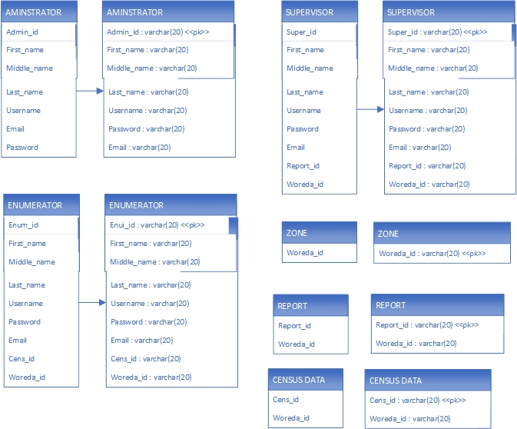 *Figure 5: conceptual modeling*

## 3.7 Sequence diagram

Sequence diagrams are used to show how objects interact in a given situation. An important characteristic of a sequence diagram is that time passes from top to bottom: the interaction starts near the top of the diagram and ends at the bottom. A popular use for them is to document the dynamics in an object-oriented system.

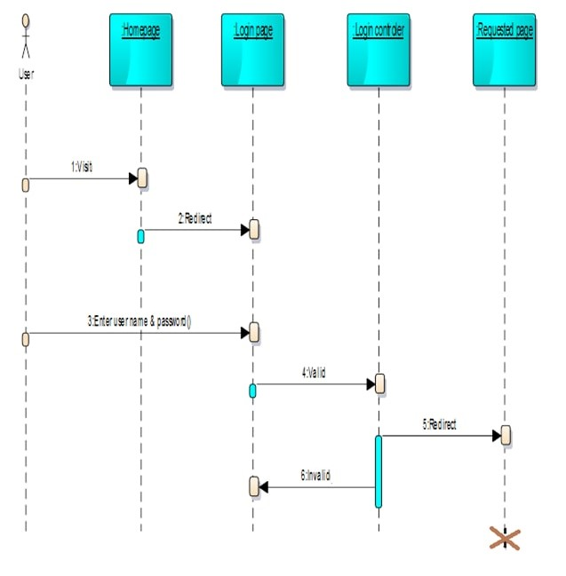

Figure 6: Sequence diagram for login

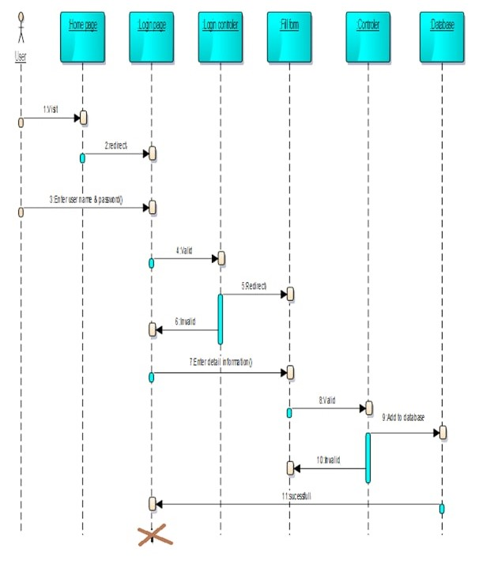

Figure 7 : Sequence diagram for fill form

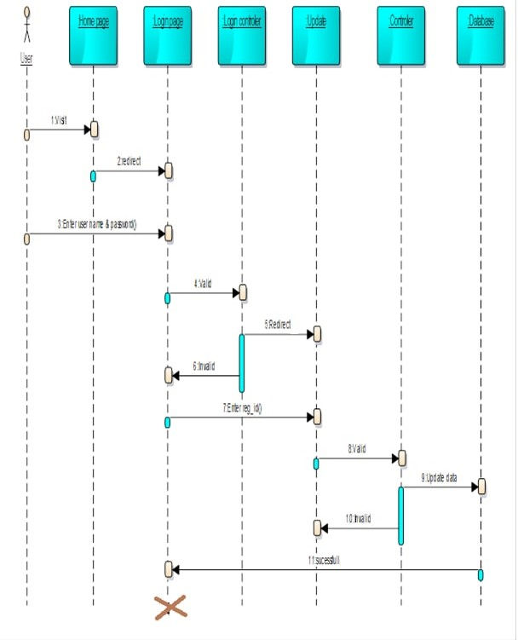

Figure 8 : Sequence diagram for update

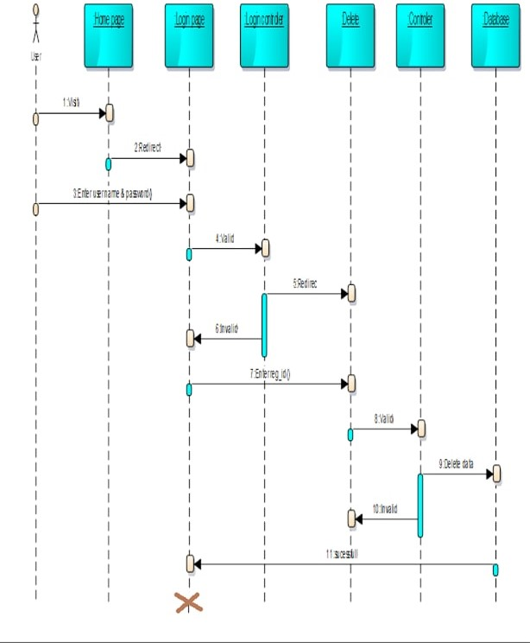

Figure 9: Sequence diagram for delete

## 3.8 Activity diagram

Activity diagrams are typically used for business process modelling, for modelling the logic captured by a single use caseor usage scenario, or for modelling the detailed logic of a business rule. Although UML activity diagrams could potentially model the internal logic of a complex operation it would be far better to simply rewrite the operation so that it is simple enough that you don't require an activity diagram. In many ways UML activity diagrams are the object-oriented equivalent of flow chart and data flow diagram (DFDs) from structured development



Figure 10 : Activity diagram for login

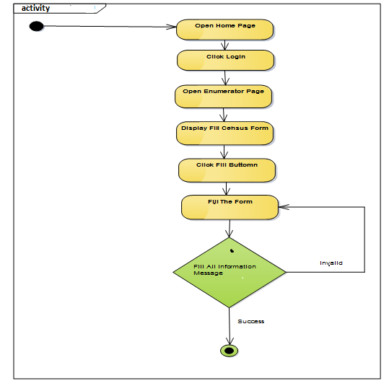

Figure 11: Activity diagram for fill

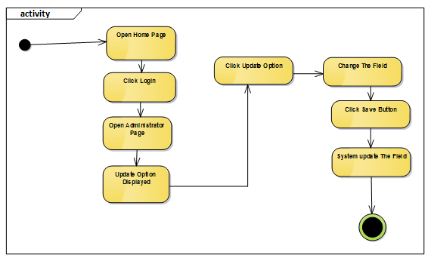

Figure 12: Activity diagram for update

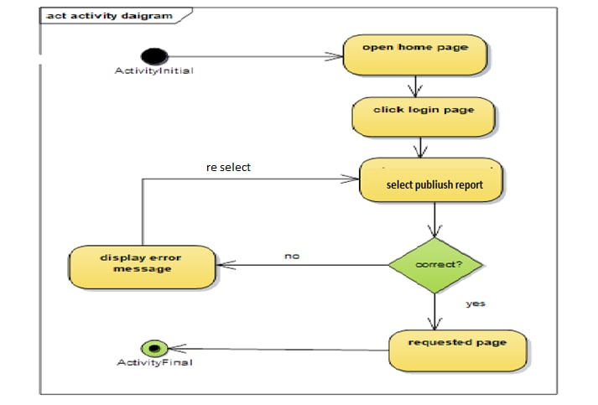

Figure 13: Activity diagram for publish

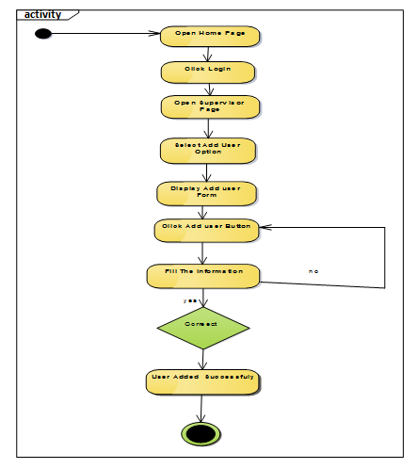

Figure 14; Activity diagram for add actor

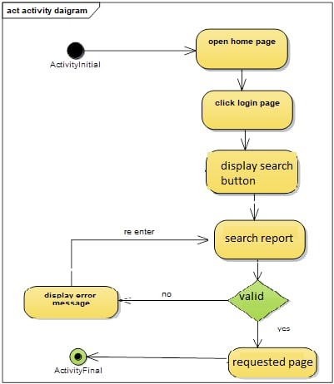

Figure 15: Activity diagram for search

## 3.9 State chart diagram

State-chart diagram describes the flow of control from one state to another state. States defined as a condition in which an object exists and it changes when some event is trigger. Therefore, the most important purpose of State-chart diagram is to model lifetime of an object from creation to termination. The main purpose of using state -chart includes to model dynamic aspects of a system, to model lifetime of an object, and to describe different states of an object during lifetime

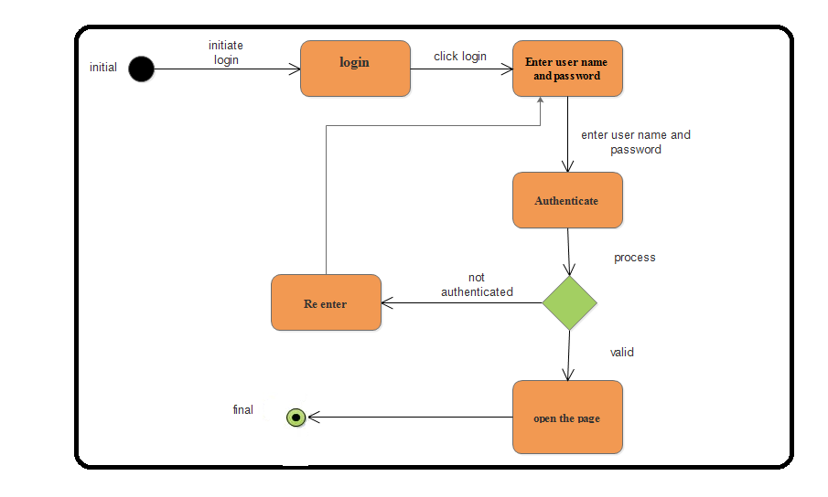

Figure 16: State diagram for login

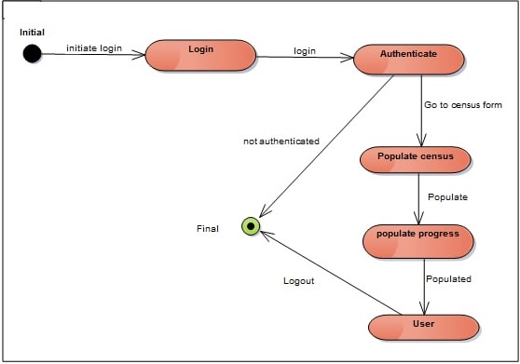

Figure 17: State diagram for populate

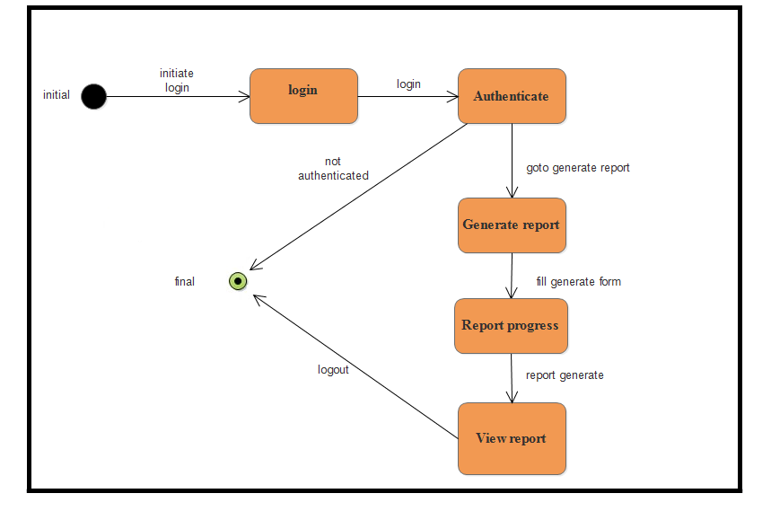

Figure 18 : State diagram for generate report

## 3.10 User interface

User Interface (UI) Design focuses on anticipating what users might need to do and ensuring that the interface has elements that are easy to access, understand, and use to facilitate those actions. UI brings together concepts from interaction design, visual design, and information architecture.

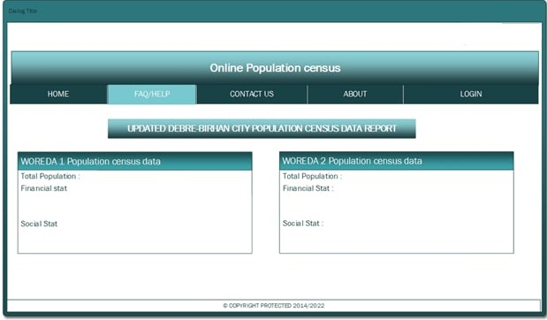

Figure 19: user interface for home page

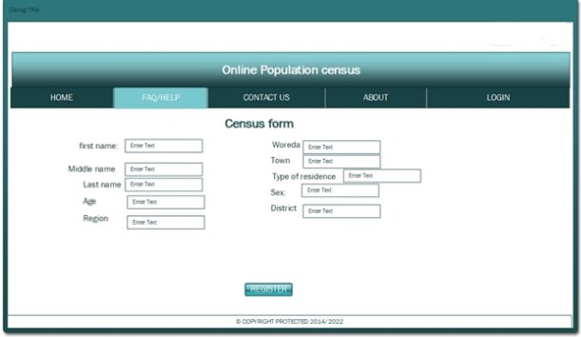

Figure 20 : user interface for fill census form

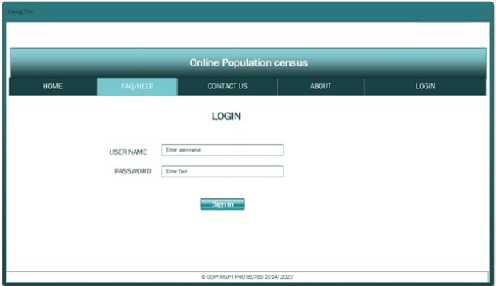

Figure 21: user interfaces for login

## 3.11 User Interface Prototyping

For the user interface below the menus are displayed as the user role. The following shows navigation path for the menu items.

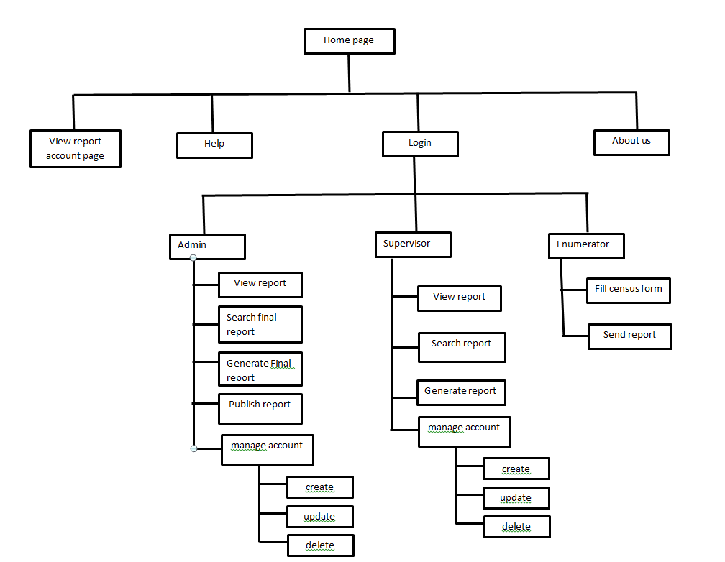

Figure 22: user interface prototype

## Supplementary specifications

### 3.12.1 Business Rules

BR1: Administrator creates Supervisor account

BR2: Supervisor creates Enumerator’s account

BR3: Unregistered Supervisor or Enumerator has no access to those privileges

BR4: Admin, Supervisors & Enumerators have to own a unique username & password to enter the system

BR5: The Admin, Supervisors & Enumerators has to use the system and input data carefully & responsibly

### 3.12.2 Constraints

**Internet**: - This system needs internet connection to be accessed.

**Time**: As we take other courses in addition to the project, workload may occur which results time constraint.

**Technical problems**: Our knowledge and experience towards project work is not that much sufficient and we kill more time on studying and understanding some references and supportive courses about project work.

# CHAPTER FOUR

# SYSTEM DESIGN

## 4.1 Introduction

The purpose of designing is to show the direction how the system is built and to obtain clear and enough information needed to drive the actual implementation of the system. It is based on understanding of the model the software built on. System design is a phase of creativity rules where customer requirements, business needs and technical considerations all come together in the formulation of the system. Design is the first step to the development phase. The objectives of design are to model the system with high quality. Implementing of a high-quality system depends on the nature of design created by the designer. Generally, this chapter describes how the project is designed, what tasks to done under the project and different modules and their way of functioning.

## 4.2 Purpose of the system

Software Design Specification Document contains design level statements regarding the system to be developed. This document is a detailed description of the system design for the online human population census system. i.e, the modules in the system and how they integrate and relate to each other. It is going to act as a guide for the system developer for it describes how system requirements contained in the requirement specification document are carried out or implemented in the system. The document would also show how users would visualize the system and detailed descriptions of the inputs, processes and anticipated outputs of specific sub-parts of the system. System Design Specification (SDS) is a description of how the anticipated functional and non-functional system requirements specified in the Software Requirements Specifications (SRS) are achieved in the system. This document generally includes the design of use case, sequence, activity diagrams.

## 4.3 **Design goal**

The design goal can be inferred from non-functional requirements which will be discussed as follows

* ***Reliabilit*y:**  Reliability is “the probability that a system will perform a required function, under stated conditions, for a stated period of time”. Our system is reliable to provide reliable service for the user.
* **Usability:** The system that we develop should be easy to learn and operate. The system interface should be user friendly.
* ***Manageability***: it is easy for system administrators to manage the application, usually through sufficient and useful instrumentation exposed for use in monitoring systems and for debugging and performance tuning.
* ***Maintainabilit*y**: is the ability of the system to undergo changes with a degree of ease. These changes could impact components, services, features, and interfaces when adding or changing the functionality, fixing errors, and meeting new business requirements. our system can be maintained easily if any change is happened.
* ***Performance***: Performance is an indication of the responsiveness of a system to execute any action within a given time interval. It can be measured in terms of latency or throughput. Latency is the time taken to respond to any event. Throughput is the number of events that take place within a given amount of time.
* ***Security***: our system prevents malicious or accidental actions outside of the designed usage, and prevents disclosure or loss of information. A secure system aims to protect assets and prevent unauthorized modification of information.
* **Robustness:** If there is any error in one module then it does not affect the remaining part of the software.
* **Correctness:** The system result should be pure and accurate.

## 4.4 System Architecture

The proposed system is developed in order to replace the current Manual dominate system into a fast and efficient way. In this case, it uses three tire architecture. Three tiers architecture is an architecture in which the functional process logic, data access, computer data storage and user interface are developed and maintained as independent modules on separate platforms.

Those 3 tires are the presentation layer (UI), Service/application tier or business logic (BL) and data tier (DB).

**The presentation layer (UI)**: -this layer is the top-level part and displays information related to services available on the server. This is the user interface displayed when the user opens the application.

**The Service/application tier or business logic (BL)**: - is the middle tier that is pulled from the user interface. It performs controlling the application functionalities by performing detailed processing. The main responsibility of this tier is connecting the user interface and the database.

**The data tier (DB):-** is a house for database servers where information is store.

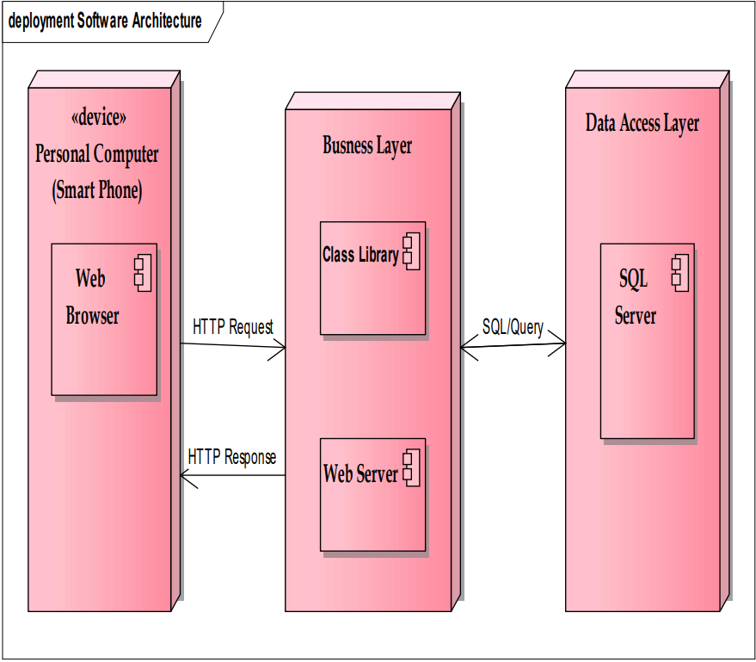

Figure 23: Software Architecture

## 4.5 Class Modelling

In order to store information persistently, we map objects into tables and the attributes into fields to the specific table based on the objects found on the system. Therefore, we identified four major tables that will be implemented in the system. For this reason, the mapping of objects to tables is displayed as follows:

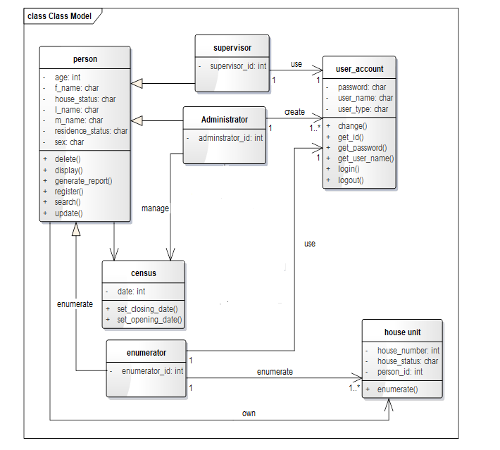

Figure 24 : Class Modeling diagram

## Component Diagram

The component diagram depicts the components of the system and their interaction. The component diagram illustrates actors and their corresponding activities.

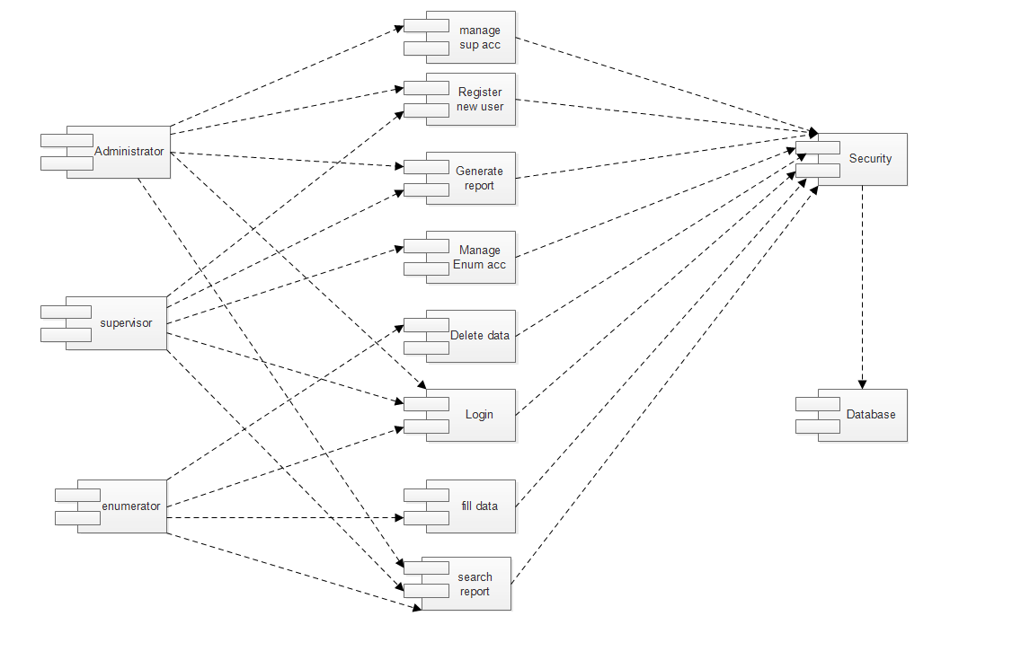

Figure 25 : component diagram

## 4.7 Subsystem decomposition

System decomposition is undertaken to reduce the complexity of the system and gaining insight into the identity of the constituent components. The system is decomposed in to sub-systems which are a collection of classes, associations, operations, events and constraints that are closely interrelated with each other.

The major subsystems of Online Population census system are described as follow: -

**Administrator**: an employee, who works on census service office, which have the following responsibilities.

* Add/ Manage Supervisor account.
* Search report.
* Generate Final report.
* Publish Report.

**Supervisor:** an employee in the census system, who is responsible to generate report and add enumerators.

* Add/ Manage Enumerator account.
* Generate report.
* Search Census Data

**Enumerator**: A professional person who performs counting functions such as enumeration of person and housing unit and fill other census form.

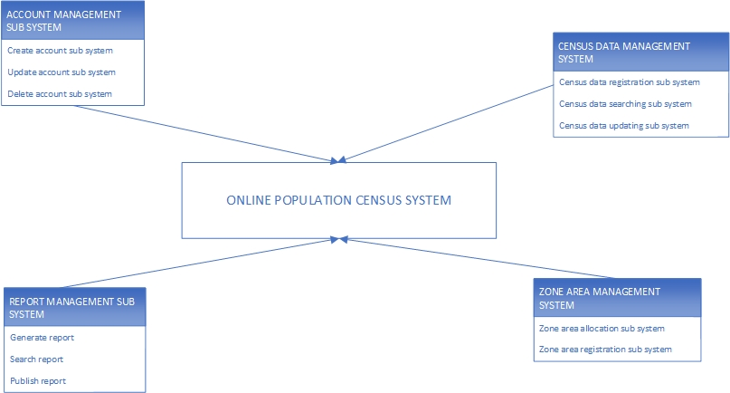

Figure 26: Subsystem decomposition diagram

## 4.8 Deployment Diagram

Deployment modelling is used to show the hardware of the system, the software that is installed in the hardware and also the middleware that is used to connect the disparate machines to one and other.



Figure 27: deployment diagram

## 4.9 Data Dictionary

This gives a brief description of the field names used in the tables and what they define as per the databases.

***Administrator Table***

|  |  |  |  |
| --- | --- | --- | --- |
| Field name | Data type | Size | Description |
| Administrator_name | Varchar | 20 | Holds the name of the Administrator |
| Administrator ID | Number | 20 | Holds the First name of the Administrator |
| first_name | Text | 20 | Holds other names of the Administrator |
| Last_name | Date time | 20 | Field for identifier of the Administrator |
| Address | Date time | 10 | Holds the contact of the Administrator |
| email | Text | 20 | Highlights the email of the Administrator |
| Phone_no. | Int | 15 | Fields holds phone number of the Administrator |
| Password | Varchar | 20 | Holds the name of the Administrator |

Table 10 *Administrator table*

***Supervisor Table***

|  |  |  |  |
| --- | --- | --- | --- |
| Field name | Data type | Size | Description |
| supervisor_name | Varchar | 20 | Holds the name of the Supervisor |
| Supervisor_id | Number | 20 | Holds the First name of the Supervisor |
| first_name | Text | 20 | Holds other names of the Supervisor |
| last_name | Text | 20 | Field for identifier of the Supervisor |
| Address | Int | 10 | Holds the contact of the supervisor |
| email | Text | 20 | Highlights the email of the supervisor |
| Phone_no. | Int | 15 | Fields holds phone number of the supervisor |
| Password | Varchar | 20 | Indicates the password |

Table 11 supervisor table

***Enumerator Table***

|  |  |  |  |
| --- | --- | --- | --- |
| Field name | Data type | Size | Description |
| Enumerator_name | Varchar | 20 | Holds the name of the Enumerator |
| Enumerator ID | Number | 20 | Holds the First name of the Enumerator |
| first_name | Text | 20 | Holds other names of the Enumerator |
| Last_name | Date time | 20 | Field for identifier of the Enumerator |
| Address | Date time | 10 | Holds the contact of the Enumerator |
| email | Text | 20 | Highlights the email of the Enumerator |
| Phone_no. | Int | 15 | Fields holds phone number of the Enumerator |
| Password | Varchar | 20 | Holds the name of the Enumerator |

Table 12 enumerator table

***Census Data***

|  |  |  |  |
| --- | --- | --- | --- |
| Field Name | Data type | Size | **Description** |
| Location | Varchar | 20 | Indicates the location for household |
| Address | Varchar | 20 | Indicates the Address for household |
| Age | int | 20 | Indicate the age of residents |
| Place_of_birth | Varchar | 20 | Indicates the birth place of residents |
| Religion | Varchar | 20 | Indicates the religion of residents |
| Marital_status | Varchar | 10 | Indicates the martial status of residence |
| Orphan_hood | Varchar | 20 | Indicates the orphan in the residence |
| Previous_residence | Varchar | 20 | Indicates the previous residence of residents |
| Nationality | Varchar | 20 | Indicates the nationality of residents |

Table 13 census data table

## 4.10 Database Design

Database modeling is used to communicate the design of the database, usually the data base to both the users and the developers. It is also used to describe the persistence data aspect of the system. The following diagram indicates the database design in diagram of the system.

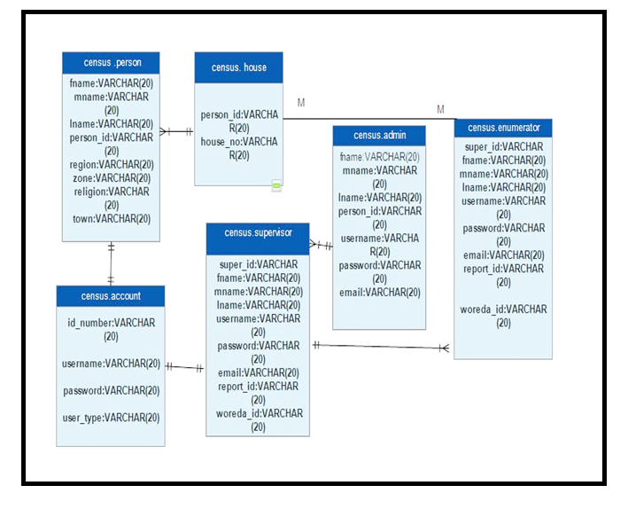

Figure 28: database design

# Reference

* G. David Garson, North Carolina state university, USA, Handbook of Research on Public Information Technology volume 1
  + Accessed on December ,2014 : http://www.census.ie/-in-history/the-census-through-history.150.1.aspx
  + Accessed on January 04,2015 : [http://www.google.com/ industry/diagram/Sequence Diagram-UML Diagrams-Unified Modeling Language Tool.html](http://www.google.com/%20industry/diagram/Sequence%20Diagram-UML%20Diagrams-Unified%20Modeling%20Language%20Tool.html)
  + Accessed on December 14,2014 : [http://www.google.com/industry/diagram/UML Class Diagram.html](http://www.google.com/industry/diagram/UML%20Class%20Diagram.html)
  + Accessed on December 10,2014 : [http://www/google.com/industry/diagram/Sequence Diagram for Login (UML)Lucidchart.html](http://www/google.com/industry/diagram/Sequence%20Diagram%20for%20Login%20(UML)Lucidchart.html)
  + Accessed on December 17,2014 : http://www.usability.gov/what-and-why/user-interface-design.html